**Enabling Windows Subsystem for Linux using Settings**

To install WSL using Setting on Windows 10, use these steps:

1. Open **Settings**.
2. Click on **Apps**.
3. Under the "Related settings" section, click the **Programs and Features** option.

*[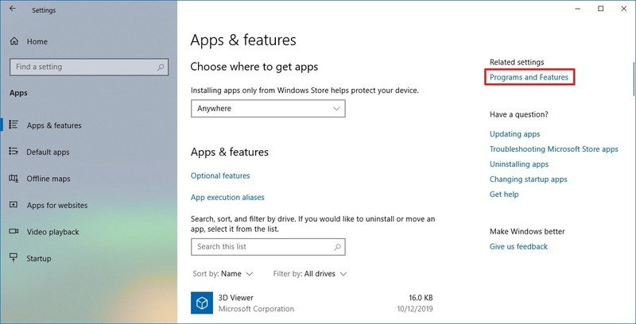](https://www.windowscentral.com/sites/wpcentral.com/files/styles/xlarge/public/field/image/2019/12/apps-features-programsfeatures-option.jpg)*

1. Click the **Turn Windows features on or off** option from the left pane.

*[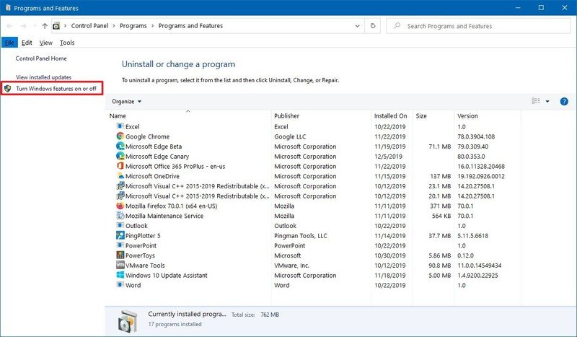](https://www.windowscentral.com/sites/wpcentral.com/files/styles/xlarge/public/field/image/2019/12/controlpanel-turn-windows-features-option.jpg)*

1. Check the **Windows Subsystem for Linux** option.

*[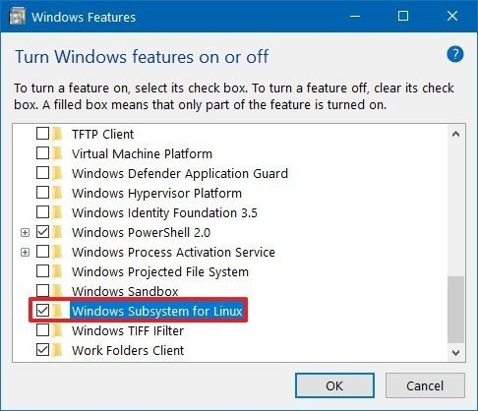](https://www.windowscentral.com/sites/wpcentral.com/files/styles/xlarge/public/field/image/2019/12/enable-windows-subsystem-linux-windows-10.jpg)*

1. Click the **OK** button.
2. Click the **Restart now** button.

Once you complete the steps, the environment will be configured to download and run the distros of Linux on Windows 10.

**Installing Linux distros(UBUNTU) using Microsoft Store**

To install a distribution of Linux on Windows 10, use these steps:

1. Open **Microsoft Store**.
2. Search for the Linux distribution that you want to install.
3. Select the distro of Linux(UBUNTU) to install on your device.

*[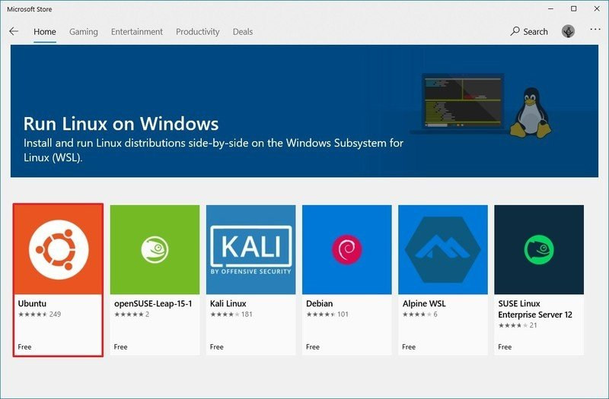](https://www.windowscentral.com/sites/wpcentral.com/files/styles/xlarge/public/field/image/2019/12/linux-microsoft-store-download.jpg)*

1. Click the **Get** (or **Install**) button.

*[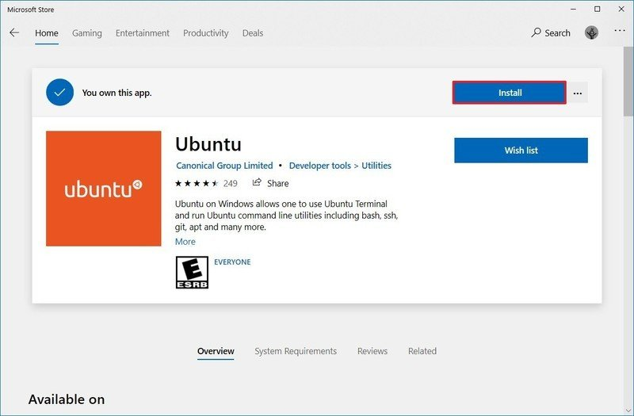](https://www.windowscentral.com/sites/wpcentral.com/files/styles/xlarge/public/field/image/2019/12/install-ubuntu-microsoftstore.jpg)*

1. Click the **Launch** button.
2. Create a username for the Linux distro and press **Enter**.
3. Specify a password for the distro and press **Enter**.

*[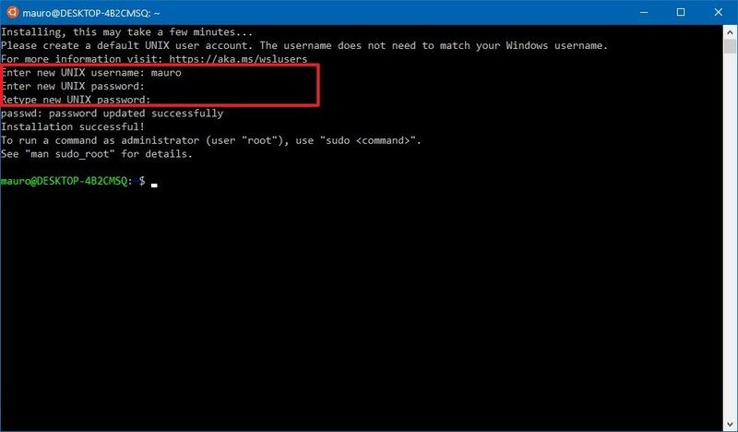](https://www.windowscentral.com/sites/wpcentral.com/files/styles/xlarge/public/field/image/2019/12/setup-ubuntu-wsl-windows10.jpg)*

Repeat the password and press **Enter** to confirm.

After you complete the steps, you can start using the distro as any other flavor of Linux.

**Install java on Ubuntu 18.04**

You should logged in on Ubuntu 18.04 server using non-root user account with sudo privileges.

OpenJDK 8 JDK is available to install from the standard Ubuntu repositories.

First update the package manager index using below command:

$ sudo apt update

Now install Java by typing following command:

$ sudo apt install openjdk-8-jdk

Once the installation is finished you can confirm installation by checking version of jdk by:

$ Java – version

# **Install Tomcat 9 on Ubuntu 18.04**

Step1 : Download the Tomcat archive in the **/tmp** directory using the following **wget** command:

wget <https://mirrors.estointernet.in/apache/tomcat/tomcat-9/v9.0.50/bin/apache-tomcat-9.0.50.tar.gz> -P /tmp

Step 2: **Create Tomcat User**

$ sudo useradd -r -m -U -d /opt/tomcat -s /bin/false tomcat

Extract the Tomcat archive and move it to the /opt/tomcat directory:

$ sudo tar xf /tmp/apache-tomcat-9*.tar.gz -C /opt/tomcat

Try to access Tomcat in browser .

Add below line in **tomcat - users .xml** document

**Path** : /opt/tomcat/apache-tomcat-9.0.50/conf/ tomcat - users .xml

**Line** : <user username="admin" password="admin" roles="manager-gui" />

**Setup DI 11 on Ubuntu 18.04** **:**

Come out of opt / folder and mount c drive

**cd mnt/c**

Access the war file from local and **copy** to webapps folder

/mnt/c/Erwin/DI11# c**p *.war** /opt/tomcat/apache-tomcat-9.0.50/webapps/

**Note** : Create a fresh database in SSMS .

Exit c drive and navigate to WEBINF folder

/opt/tomcat/apache-tomcat-9.0.50/webapps/erwinDISuite11# **cd WEB-INF/**

**Edit database properties file :**

/opt/tomcat/apache-tomcat-9.0.50/webapps/erwinDISuite11/WEB-INF/database# **vi database.properties**

On INSERT mode to edit the document and navigate the document using arrow keys .Escape from INSERT mode and use save or quit option.

Save : :w!

Quit : :q!

**Edit icc documents :**

/opt/tomcat/apache-tomcat-9.0.50/webapps/erwinDISuite11/WEB-INF/configuration/properties# **vi iccdocuments.properties**

Give both paths : /opt /

Save and quit

Shutdown and start tomcat